{Part 3}

{RIP}

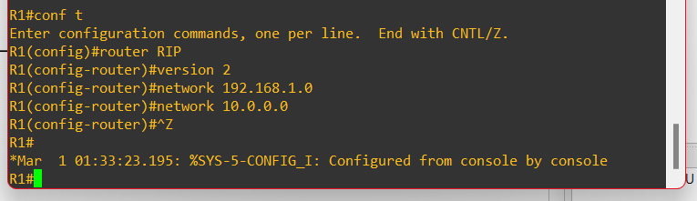

Image 3.1 : setting up the R1’s RIP configurations according to the instruction provided

Network 192.168.1.0

Network 10.0.0.0

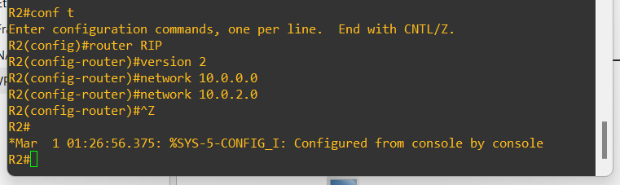

Image 3.2 : setting up the R2’s configurations according to the instructions provided

Network 10.0.0.0

Network 10.0.2.0

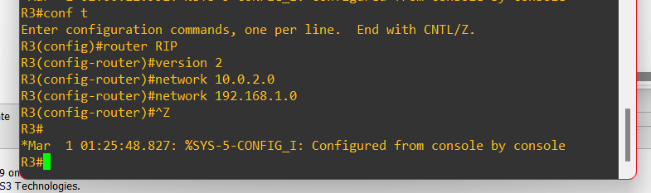

Image 3.3 : setting up the R3’s configurations according to the instructions provided

Network 10.0.2.0

Network 192.168.1.0

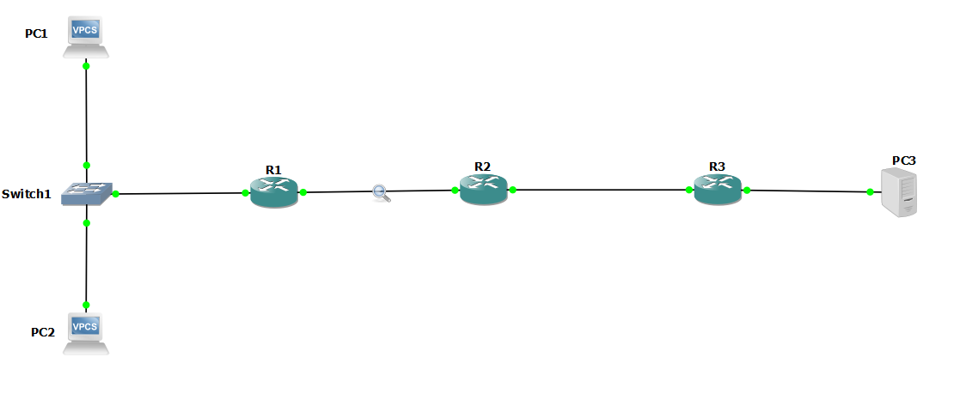

Image 3.4 : Checking the traffic with any connection between the routers (R1 and R2 is checked here)

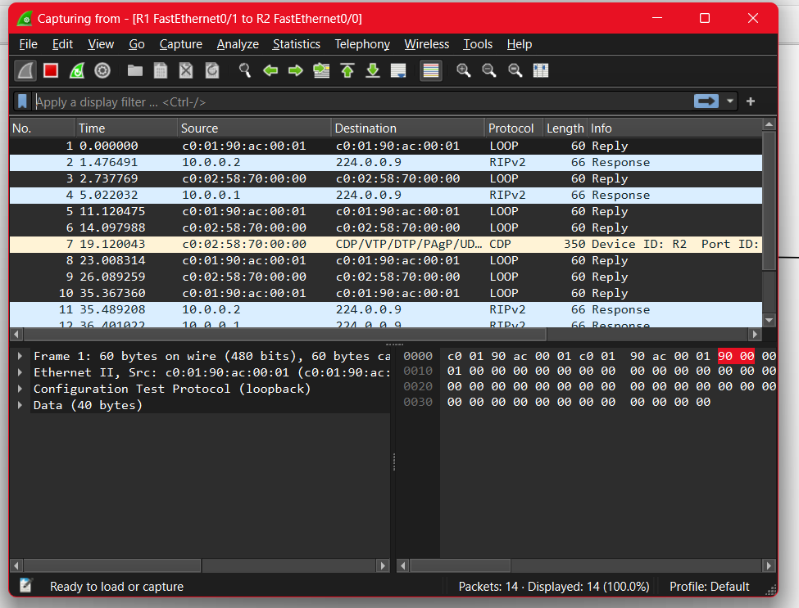

Image 3.5 : Observing the traffic on the link between R1 and R2 using Wireshark

Here , we can see that the RIP updates in RIPv2 use multicast with the IP address 224.0.0.9, instead of broadcasting to 255.255.255.255. This reduces network traffic because the updates are only sent to specific routers that need them, lowering overall network load.